# Preparing the Source Routes and Calibration Points

## Create Routes Process

Since there are multiple fields for RouteId and measures I needed to create a single field for each to populate all the routes. I had exported out a copy of the RoadCenterlines feature class called RoutesSource, so I didn’t edit the source data. Below is the logic I used for Iteration 1.

1. Add 3 Fields to RoutesSource
   1. SourceRouteId (Text, 50)
   2. SourceFromMeasure (Double)
   3. SourceToMeasure (Double)
2. Populate the fields:
   1. Select LRS_ROUTE_PREFIX IN ('I', 'U', 'K')
      1. populate SourceRouteId with StateKey1
      2. populate SourceFromMeasure with STATE_BEGIN_MP
      3. populate SourceToMeasure with STATE_END_MP
   2. Select LRS_ROUTE_PREFIX NOT IN ('I', 'U', 'K') AND LRSKEY IS NOT NULL
      1. populate SourceRouteId with LRSKEY
      2. Calculate SourceFromMeasure with NON_STATE_BEGIN_MP
      3. Calculate SourceToMeasure with NON_STATE_END_MP
   3. Select LRS_ROUTE_PREFIX IN ('C') and LRSKEY not like '%W0'
      1. Populate SourceRouteId with left([LRSKEY],11)&"W0"

Note: This does not include the logic to populate the RouteId and measures for the brand-new routes coming from the conflated dataset, since these routes have no business data; they are not high priority.

1. Use the Create Routes GP tool (Linear Referencing toolbox). Output: Routes

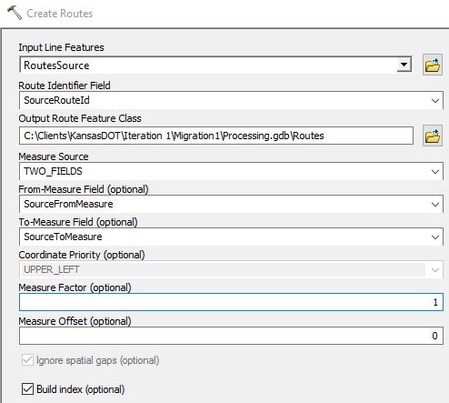

## Creating Calibration Points

Points need to be created at the beginning and end of each segment in the RoadCenterlines feature class. Use the RouteSource feature class from the create route process for the steps below.

1. Open the attribute table for the RouteSource feature class
2. Turn off all the fields in the RouteSource table except:
   1. SourceRouteId
   2. SourceFromMeasure
3. Create points at the beginning of route sections using the Feature Vertices To Points (Data Management/Features toolbox). Output: Start

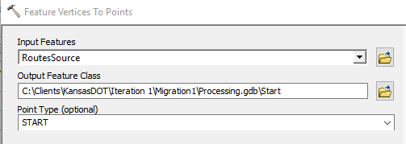

1. In the RouteSource table, turn off the SourceFromMeasure and turn on SourceToMeasure
2. Create points at the end of route sections using the Feature Vertices To Points (Data Management/Features toolbox). Output: End

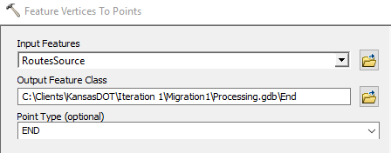

1. Merge the resulting point feature classes together. Output: CalPts_Merge
   1. Change the field names in the Field Map section to RouteId and Measure

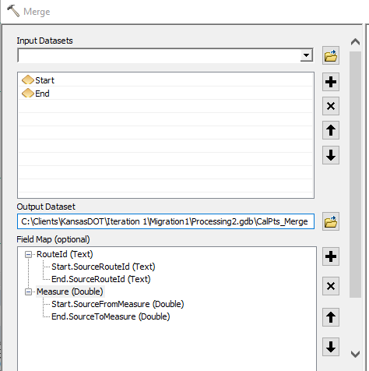

1. Dissolve CalPts_Merge on RouteId and Measure. Uncheck Create multipart features. Output: CalPts

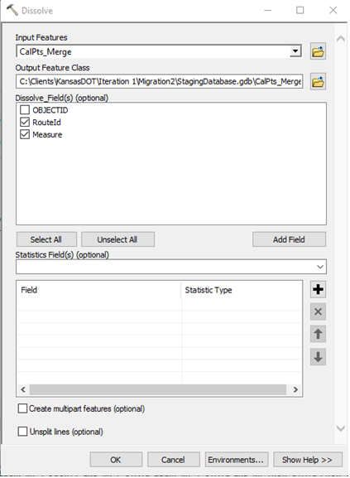

## Data Reviewer Batch Job

<http://desktop.arcgis.com/en/arcmap/10.4/extensions/data-reviewer/batch-jobs-and-data-reviewer.htm>

Above is the link to Esri’s Resource Center for Data Reviewer batch jobs. In the Reviewer Batch Job Manager, open the SourceChecks.rbj. Edit the checks to point to the Routes and CalPts feature class you created in the steps above.

Note: When executing this batch job, it can take a lengthy amount of time to run against the entire database. It might be better to choose one of the other options in the Batch Validate window. The link below will take you to the help documentation to executing a batch job.

<http://desktop.arcgis.com/en/arcmap/10.4/extensions/data-reviewer/validating-data-with-batch-jobs-using-the-reviewer-batch-validate-tool.htm>